MECE Breakdown for Northwind Sales Analysis

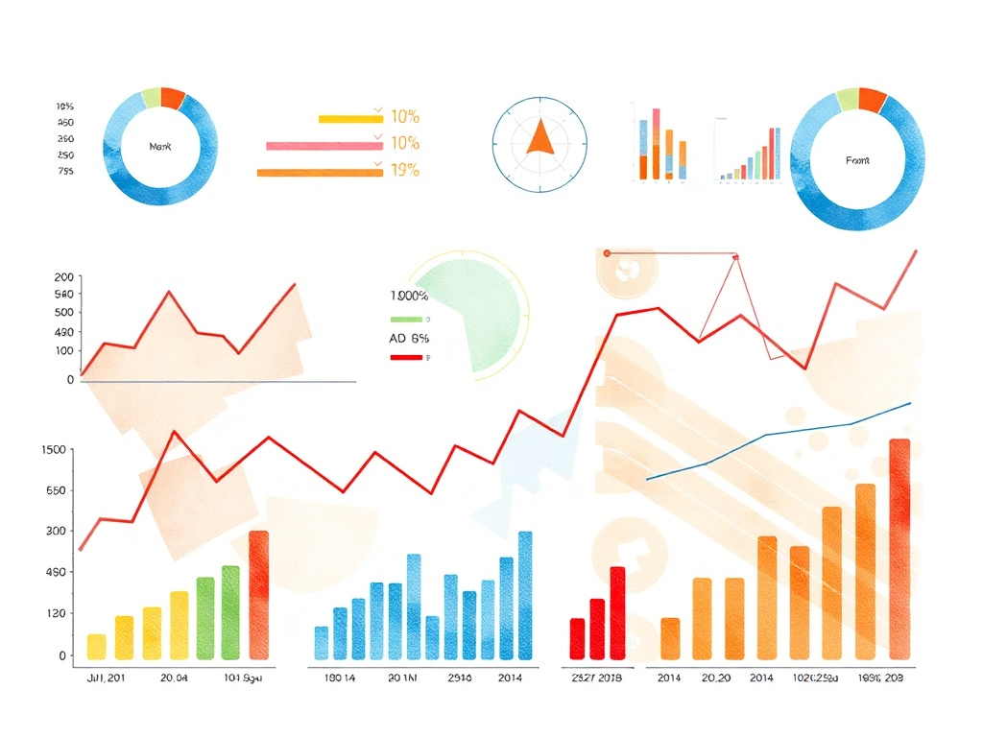

Objective
To analyze Northwind’s sales performance across revenue, customers, products, geography, and operations in a mutually exclusive and collectively exhaustive (MECE) manner to generate actionable business insights.

Revenue distribution by Country | Revenue distribution by City | Revenue distribution by region
The objective of this analysis is to understand how revenue is distributed across different countries and identify key revenue-driving markets. | The key objective of this analysis is to identifies the highest revenue generate by the customers belongs to which city. | The objective of this analysis is to understand how revenue is distributed across different cities in product wise and identify key revenue-driving markets in city wise.
Customer Base Overview | Customer Order Behavior | Customer Segmentation
In this matrix, the major focus is getting the information about the total customer in city wise or country wise, out of that how many active customers are there. | This helps to know about the customer buying behaviors by separating the customer based on the average order and their repeat rate. | In this, we can fit the customers based on the different segments like:  High value customers  Medium-value customers  Low-value customers
Category Performance | Product Performance | Pricing & Demand Analysis
This matrix focuses on the Product-level profitability and demand.it evaluates the sales by category , quantity sold and revenue contribution of the different product category. | Evaluate the performance of the products based on the top 10 products by revenue, lowest performing products, high revenue but low quantity products. | The main purpose is to identifies the most demanded products on market based on the price. By evaluating average unit price by category, sales vs quantity relationship, discount impact.
Order value Analysis | Shipping Analysis | Order Volume
Evaluate average order value and overall order size distribution across the countries. | Evaluate the delivery performance or standard duration of the delivery of the product and order by shipper. | Evaluate the total order of the product by calculating total orders and order over time.
Growth trend | Seasonality | Sales spike
Focuses on sales over time (monthly, yearly, quarterly). This analysis tracks how revenue changes over time. | Seasonality means recurring patterns in specific months or special occasion like festive season sales etc. | Spikes are sudden increases in revenue in specific months or Day.
Revenue Distribution
Trend Analysis

Order and supply Analysis

Product & Category Performance

Customer performance Analysis

